1. **PURPOSE:** Safe testing/checking of chain pulley block for safe working operation
2. **SCOPE:** Battery-1, Battery 2 & Jetty
3. **RESPONSIBILITY:** Engineer In charge & Maintenance Fitter on job
4. **SAFETY PRECAUTIONS:**
   * Job to be carried out by Competent Person authorized by Inspector of Factories & Boilers .
   * Ensure that workplace is clean and safe.
   * Exercise caution while lifting, hanging of chain block for load test and removal.



1. **PPE to be used :**
   * Safety Helmet
   * Safety shoes
   * Safety Goggles
   * Hand gloves
   * Reflector jacket.
2. **BASIC COMPONENTS**

Key Components :

* Upper Hook
* Lower Hook(load hook)
* Hook Latch
* Hoist Frame
* Load chain
* Hand chain

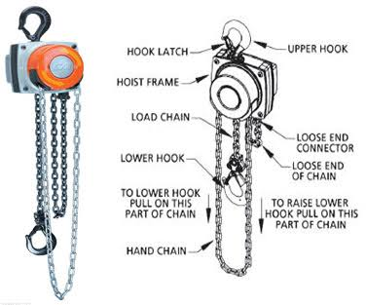

1. **Activities**

* Activity No 1 : Checking & load test of chain blocks (Frequency-Annual)
* Activity No 2 : Periodic inspection of chain block (Frequency-Monthly)

1. **Aspect-Impact:**

|  |  |
| --- | --- |
|  |  |
|  |  |

|  |  |
| --- | --- |
|  |  |
|  |  |
|  |  |

1. **Hazards** **identified**
2. Physical Hazard

* Dust

1. Mechanical Hazard

* Trip, Entanglement ,Trapping, Object fall from height

1. Human behaviour aspect of operators:

* Alcoholism.
* Casual approach.
* Horse play.
* Non usage of PPE’s
* Improper Housekeeping

**Activity No 1: Checking & load test of chain blocks (Frequency-Annual)**

This activity has to be carried out in presence of the external competent person approved by Goa Factory Inspector.

1. Physically inspect load chain & hand chain of chain pulley block for no twist/breakages. Inspect all other items as per the catalogue of chain pulley block ( cover, holding hook, all bolts, latch)
2. Check lifting chain & wheel for free operation.
3. Hook the chain pulley block to the safe support at designated place.
4. Ensure smooth movement of chain pulley block.
5. Cordon the area coming under the approach of chain pulley block testing
6. Arrange suitable concrete weights (1.25 times the safe working load of chain pulley block) for testing.
7. Load test of chain blocks to be carried out at Shubham contractor yard with designated known weights
8. Lift the test weight for 1 meters height with the usage of certified sling and hold for at least half an hour under close supervision.
9. If the chain pulley block is accepted by the competent agency , shift the chain pulley block to the appropriate location of usage.
10. If the chain pulley block is not accepted , discard the same and report to the engineer incharge for disposal.
11. Ensure that proper , legible & unique identification no is seen on the chain block under inspection, else complete before certification.
12. Ensure that proper color coding(done after inspection & certification every quarter) is marked, else complete before certification.
13. Document the details of load test done with all details.

**Activity No 2 : Periodic inspection of chain block (Frequency-Monthly)**

* 1. This activity has to be carried out in presence of the *external competent person* approved by Goa Factory Inspector.
  2. Physically inspect load chain & hand chain of chain pulley block(CPB) for no twist/breakages. Inspect all other items as per the catalogue of chain pulley block ( cover, holding hook, all bolts, latch) & document in monthly checklist for CPB
  3. Check lifting chain & wheel for free operation.
  4. Hook the chain pulley block to the safe support at designated place.
  5. Ensure smooth movement of chain pulley block.
  6. If the chain pulley block is not accepted , discard the same and report to the engineer incharge for disposal.
  7. Ensure that *proper , legible & unique identification* no is seen on the chain block under inspection, else complete before certification.
  8. Ensure that *proper color coding*(done after inspection & certification every quarter as per guidelines) is marked, else complete before certification.

**CHECK FOR FOLLOWING:**

1. **LOAD HOOK :**

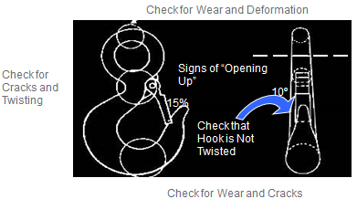

**Rejection Criteria: Hook**

* Hook throat has increased by more than 15%
* Wear exceeds 10% of the original hook section dimension, or there is a bend or twist of more than 10% from the plane of the unbent hook
* Hook shows cracks, excessive nicks, or gouges

***INCORRECT PRACTICE***

1. **SAFETY LATCH:**

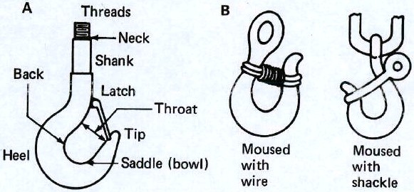

* Purpose is to retain slings in the hook
  + Not intended to support the load
  + Should be sturdy enough to retain the sling if the moving load should catch on something
* Latches are used to close the throat opening
* Must be provided on hoist and crane hooks

1. **REFERENCES:**
2. Previous test certificate for annual recertification of chain block
3. Previous monthly checklist
4. List of chain pulley block with responsible engineer
5. SP 44 H Work Instructions for Material Shifting
6. SP 44 I Work Instruction for Inspection of Structures
7. **REFERENCES:**

* Chain pulley block proof load test : IS 3832-2005 ( Carried out at factory at 1.25xSWL)
* Light load test : IS 3832-2005 ( Test with 25-50 % WLL)

1. **RECORDS:**

|  |  |  |  |  |  |
| --- | --- | --- | --- | --- | --- |
| **Sr. No.** | **Record No.** | **Record Title** | **Maintained by** | **Soft/Hard form** | **Retention Time** |
| 1. |  | Test certificate | Mechanical | Hard | 1 year |
| 2 |  | Monthly checklist-CPB | Mechanical | Hard | 1 year |



|  |  |  |  |
| --- | --- | --- | --- |
| **Date** | **Manual Section Ref. & Para** | **Brief details of Revision** | **New Rev.** |
| 13-08-2022 | Header | Company logo & Document no. | 03 |
|  |  |  |  |
|  |  |  |  |

|  |  |  |
| --- | --- | --- |
| **Prepared By:**  Head Mechanical Maintenance, Battery 1- MCD | **Reviewed & Issued By:**  Management Representative | **Approved By:**  Head Mechanical Maintenance MCD |
| **Signature:** | **Signature:** | **Signature:** |
| **Review Date: 13.08.2022** | **Review Date: 13.08.2022** | **Review Date: 13.08.2022** |